**Sales Data Analysis**

[**Link for Google Sheet Solution**](https://docs.google.com/spreadsheets/d/1LsmG74YnCGnqMzi0MXS5bb-1T505fkpubbdsRDMtIhY/edit?gid=1221437970#gid=1221437970)

|  |  |
| --- | --- |
| **Sales Table** | **Return Table** |
| **CustomerID** | **CustomerID** |
| **OrderID** | **ReturnDate** |
| **Sales** | **ReturnSales** |
| **TransactionDate** | **OrderID** |

**A) What % of sales result in a return?( In terms of No of sales )**

**Solutions:**

with t1 as

(select s.CustomerID,s.TransactionDate,s.Sales,s.OrderID,r.total_returnsales from sales s left join

(select OrderID,sum(returnsales) as total_returnsales from returns group by orderid) r

on s.OrderID=r.orderid

)

select format((select count(*) from t1 where total_returnsales is not null)*1.00/count(*),'0.00%') from t1; 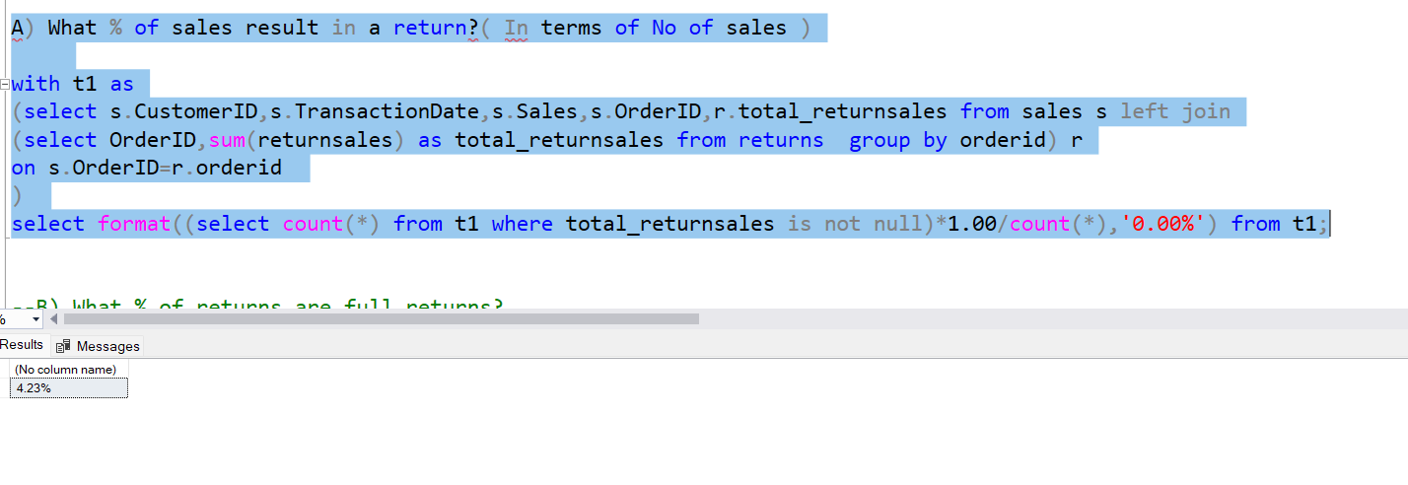

**Answer 4.23%**

**B) What % of returns are full returns?**

**Solutions:**

with t1 as

(select s.CustomerID,s.TransactionDate,s.Sales,s.OrderID,r.total_returnsales from sales s left join

(select OrderID,sum(returnsales) as total_returnsales from returns group by orderid) r

on s.OrderID=r.orderid where total_returnsales is not null

)

select format((select count(*) from t1 where sales=total_returnsales)*1.00/count(*),'0.00%') from t1;

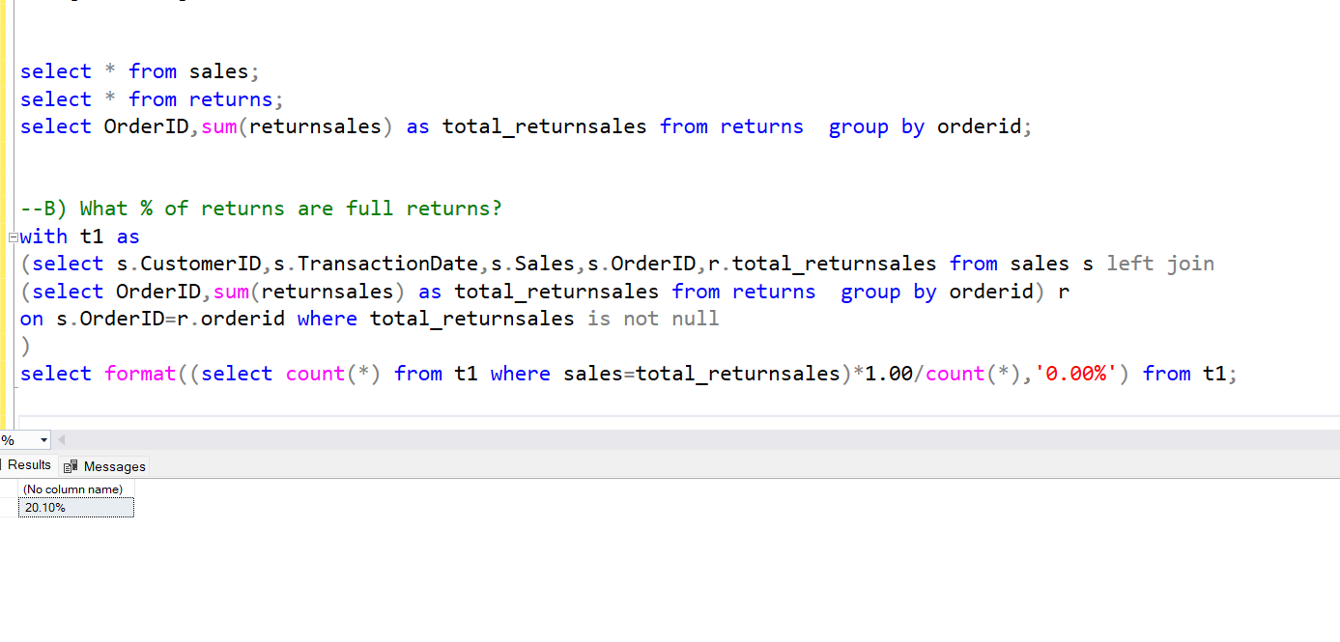

**Answer** 20.10% of the returns are full return.

**C) What is the average return % amount (return % of original sale)?**

**--Note:::Considering only orders wich are returned**

**Solution**: with t1 as

(select s.CustomerID,s.TransactionDate,s.Sales,s.OrderID,r.total_returnsales from sales s left join

(select OrderID,sum(returnsales) as total_returnsales from returns group by orderid) r

on s.OrderID=r.orderid where total_returnsales is not null

)

select format(AVG(total_returnsales)/AVG(sales),'0.00%') from t1

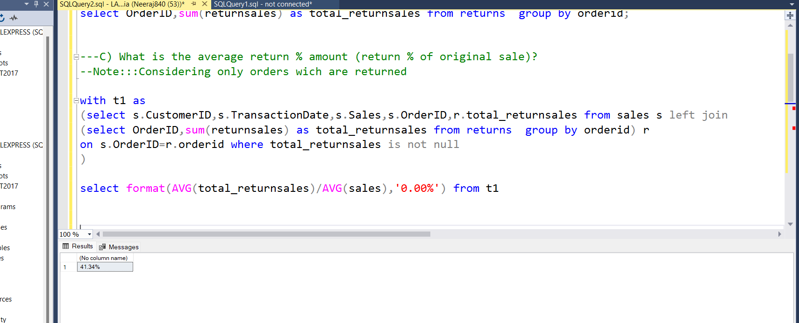

**Ans 41.34%**

**D) What % of returns occur within 7 days of the original sale?**

with t1 as

**Solution:**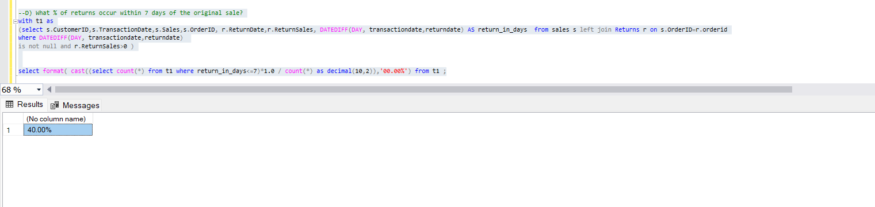

(select s.CustomerID,s.TransactionDate,s.Sales,s.OrderID, r.ReturnDate,r.ReturnSales, DATEDIFF(DAY, transactiondate,returndate) AS return_in_days from sales s left join Returns r on s.OrderID=r.orderid

where DATEDIFF(DAY, transactiondate,returndate)

is not null and r.ReturnSales>0 )

select format( cast((select count(*) from t1 where return_in_days<=7)*1.0 / count(*) as decimal(10,2)),'00.00%') from t1 ;

**Ans 40%**

**E) What is the average number of days for a return to occur?**

**Solution:**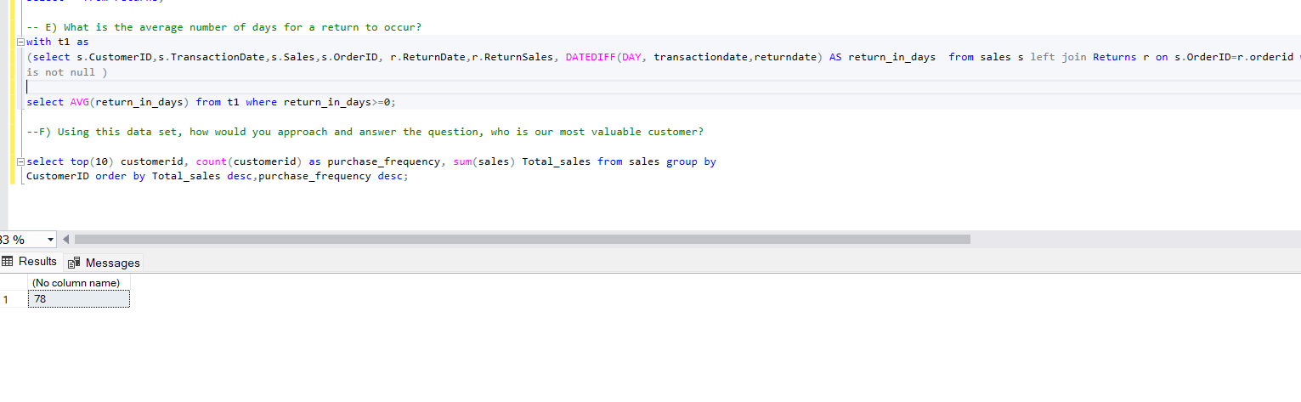

with t1 as

(select s.CustomerID,s.TransactionDate,s.Sales,s.OrderID, r.ReturnDate,r.ReturnSales, DATEDIFF(DAY, transactiondate,returndate) AS return_in_days from sales s left join Returns r on s.OrderID=r.orderid where DATEDIFF(DAY, transactiondate,returndate)

is not null )

select AVG(return_in_days) from t1 where return_in_days>=0;

**Ans: Average return days for any order_id if it is returned is 78 days.**

**F) Using this data set, how would you approach and answer the question, who is our most valuable customer?**

**Ans**: customer with customer_ID **RIVES87271** has maximum sales amount and well as customer **RACG3**  shops more frequently, hence these 2 customers are very important in terms of retentation value.

